# SIS – SoftUni Information Services

SIS is a combination of a Web Server and a MVC Framework. Ultimately it is designed to mimic Microsoft’s IIS and ASP.NET Core. Following several Lab documents you will build all components of the SIS.

# SIS: Handmade HTTP Server

Problems for exercises and homework for the [“C# Web Development Basics” course @ SoftUni](https://softuni.bg/courses/csharp-web-development-basics).

Following to the end this document will help you to create your own very simple HTTP Server. Later in the course we will extend it by adding sessions, cookies etc. We will eventually build a MVC Framework, with which we can build MVC Web Application which will be hosted on the Handmade HTTP Server.

## Solution Architecture

First, we will create the initial Solution Architecture. Create a **Solution** called “SIS” and create **2 Class Library projects** in it:

* SIS.HTTP
* SIS.WebServer

## SIS.HTTP Project Architecture

The HTTP Project will hold all of the models (and their interfaces) which will be used to implement the HTTP Communication over the TCP Link between the Client and our Server. Naturally, we can work with plain strings and byte arrays, but it will be much more comfortable if everything has its own class and its own place in the code.

Create the following namespace architecture in the project:

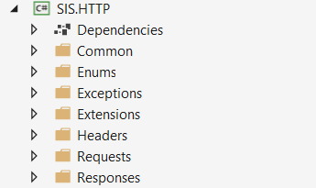

As you can see the folder architecture is quite segregated. Now let’s start filling the folders with our classes.

### Common Namespace

The Common namespace will hold classes which are commonly used in the whole project. One such class is the GlobalConstants class.

#### GlobalConstants

Create a static class, called GlobalConstants, which we will use for our shared constants:

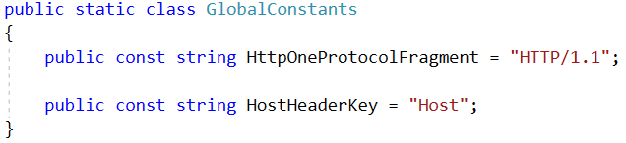

These are the only constants we will need for now.

### Enums Namespace

The Enums namespace will hold our **enumerations**. There are **2 enumerations** we will need for the current implementation of the server – HttpRequestMethod and HttpResponseStatusCode.

#### HttpRequestMethod

Create an enumeration, called HttpRequestMethod, which will be used to **define** the **method** of the **request** our Server is receiving.

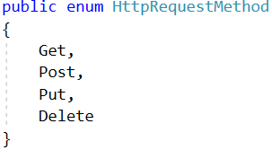

Our Server will support only GET, POST, PUT and DELETE requests. There is no need for it to process more complex requests for now.

#### HttpResponseStatusCode

Create an enumeration, called HttpResponseStatusCode, which will be used to **define** the **status** of the **response** our Server will be sending. This **enumeration** should hold **values** which are the **statuses** and **integer values** which will be the **codes.**

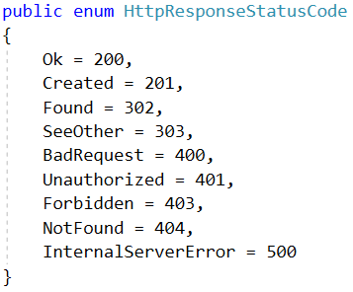

For now, our simple handmade web server **does NOT need** to support other **HTTP status codes**. These are quite enough for a normal communication between a client a server.

### Exceptions Namespace

The Exceptions namespace will hold classes which will be used for error handling on the Server. There will be 2 such exception classes for now – BadRequestException and InternalServerErrorException.   
Those exceptions will be used as a promise, that the Server will **always** **return** a **Response**, even in the **rare event** of a **Runtime Error**.

The Server will catch errors of BadRequestException type, first. If it catches an error of this type, a 400 Bad Request Response will be returned, with the Exception’s message as content.

Any other errors will be caught as InternalServerErrorException or the base Exception. In that case, a 500 Internal Server Error will be returned, with the InternalServerErrorException’s message as content.

#### BadRequestException

Create a class, called BadRequestException. This exception will be thrown when there is an error with the **parsing** of the **HttpRequest**, e.g. **Unsupported HTTP Protocol**, **Unsupported HTTP Method**, **Malformed Request** etc.

The class should **derive** from the Exception class, and should have a **default message**:

“The Request was malformed or contains unsupported elements.”

#### InternalServerErrorException

Create a class, called InternalServerErrorException. This exception will be thrown whenever there is an error that the Server was not suppoused to encounter.

The class should **derive** from the Exception class, and should have a **default message**:

“The Server has encountered an error.”

### Extensions Namespace

The Extensions namespace will hold classes with helpful extension methods – helper methods… Good Ol’ C#. There will be **2 classes** which you’ll have to implement – HttpResponseStatusExtensions and StringExtensions.

#### HttpResponseStatusExtensions

Create a class, called HttpResponseStatusExtensions. In the class, implement an HttpResponseStatusCode extension method GetResponseLine(), which **returns** the **response line** of the current status code.

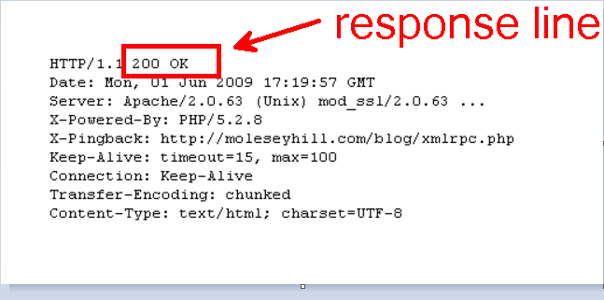

These are the **response lines** for the **codes** we have implemented:

 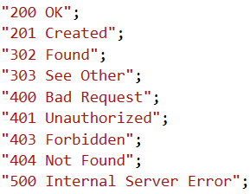

These are the results you must return, each with its corresponding code.

#### StringExtensions

Create a class, called StringExtensions. In the class, implement a string extension method called Capitalize(), which literally just **capitalizes** the **String** (makes the **first letter** – **capital** and **all other** – **lowercase**).

### Headers Namespace

The Headers namespace will hold the **classes** and **interfaces** which will be used to **store** the **data** of the **HTTP Headers** of the **Requests** and **Responses**.

#### HttpHeader

Create a class, called HttpHeader, which will be used to store data about a **HTTP Request / Response** **Header**.

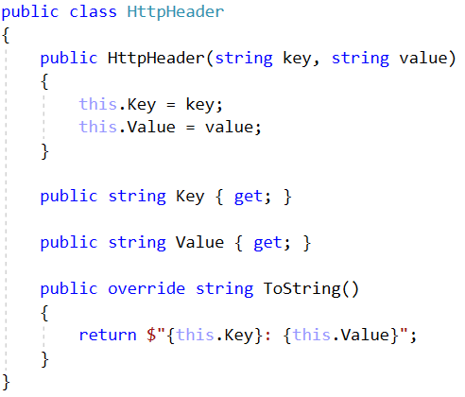

The key will be the **header’s name**, and the value – its **value**. There is also a useful ToString() method, which brings a well-formatted **web ready** (it can be used in web communication **without further formatting**) string representation of the header.

#### IHttpHeaderCollection

Create an interface, called IHttpHeaderCollection, which will describe the behaviour of a **Repository-like object** for the HttpHeaders.

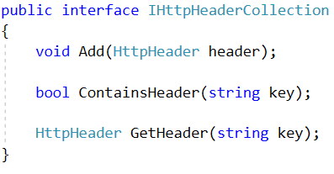

#### HttpHeaderCollection

Create a class, called HttpHeaderCollection, which implements the IHttpHeaderCollection interface. The class is a Repository-like class. It should hold a Dictionary collection of Headers and should implement the interface’s methods:

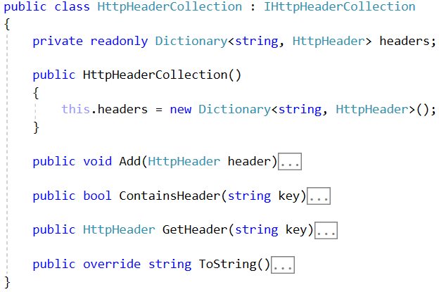

Implement each of these methods with the following functionalities:

* Add() – **adds** the header to the Dictionary collection with key – the key of the Header, and value – the Header.
* ContainsHeader() – the main reason for the use of a Dictionary. **Fast search** using the Dictionary’s hashtable. Returns a boolean result **depending** on weather the collection **contains** a Header with the **given key**.
* GetHeader() – **retrieves** from the collection and **returns** the Header with the **given key**, **if present**. If there is **NO such** Header, the method should return null.
* ToString() – **returns all** of the Headers’ **string representations**, **separated** by **new line** (“/r/n”). or Environment.NewLine.

### Requests Namespace

The time has come for us to aggregate everything into the main functionality classes.

The Requests namespace will hold classes and interfaces for storing and manipulating data about HTTP Requests.

#### IHttpRequest

Create an interface, called IHttpRequest, which will describe the behaviour of a **Request object**.

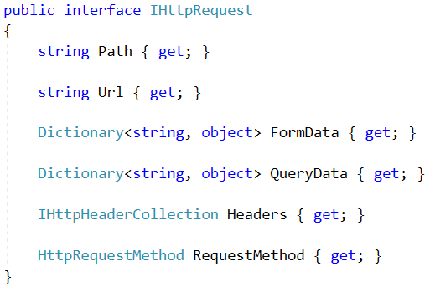

#### HttpRequest

Create a class, called HttpRequest, which implements the IHttpRequest interface. The class should implement the Interface’s methods,

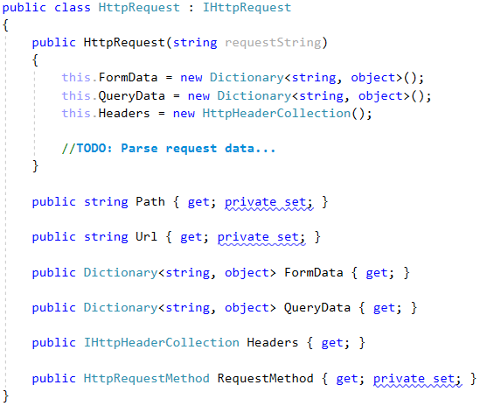

As you can see the HttpRequest holds its Path, Url, RequestMethod, Headers, Data etc. Those things come from the requestString, which is passed to its constructor. That’s how a HttpRequest should be instantiated.

The requestString will be something in the following format:

{method} {url} {protocol}  
{header1key}: {header1value}  
{header2key}: {header2value}  
...  
<CRLF>  
{bodyparameter1key}={bodyparameter1value}&{bodyparameter2key}={bodyparameter2value}...

**NOTE**: As you should already know, the body parameters are optional.

Now let’s **destructure** a **normal request** and see how we should **map** each of its **components** to our **class**’s **properties**.

##### GET Request

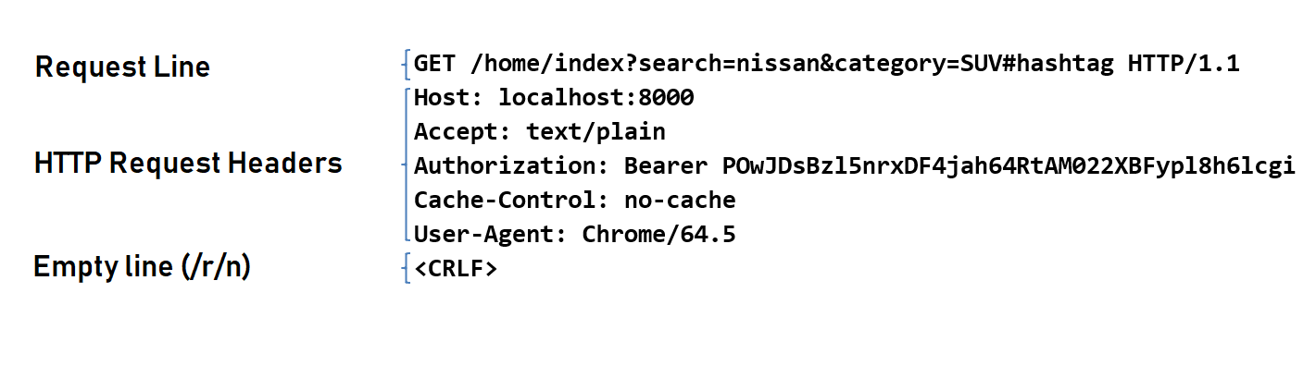

Request Line: The request line is simple, it holds:

* The Request Method – The method however, is completely uppercase, which means you must somehow format it in order for you to be able to parse it into the HttpRequestMethod Enumeration.   
  (**NO** switch / cases and if / else’s).
* The Request URL – The whole URL, holding the Path, the Query String and the Fragment.
  + Extract the Path by splitting and formatting the URL, and map it to the Path property.
  + Extract the Query string and map its parameters to the Query Data Dictionary. Parameters should be mapped as follows: parameterName = key, parameterValue = value.
  + Fragments are mostly used on the client side, so there is no need to store them in our class, thus there is no property for them.
* The Request Protocol – It **MUST** be equal to “HTTP/1.1”.

Request Headers – They can easily be **parsed** in the following format “{key}: {value}” you just have to **split** **them**, and **create** an **instance** of HttpHeader, then add it to the Headers of the **Request**.

Empty Line – Denotes the end of the **Request** **Headers**.

##### POST Request

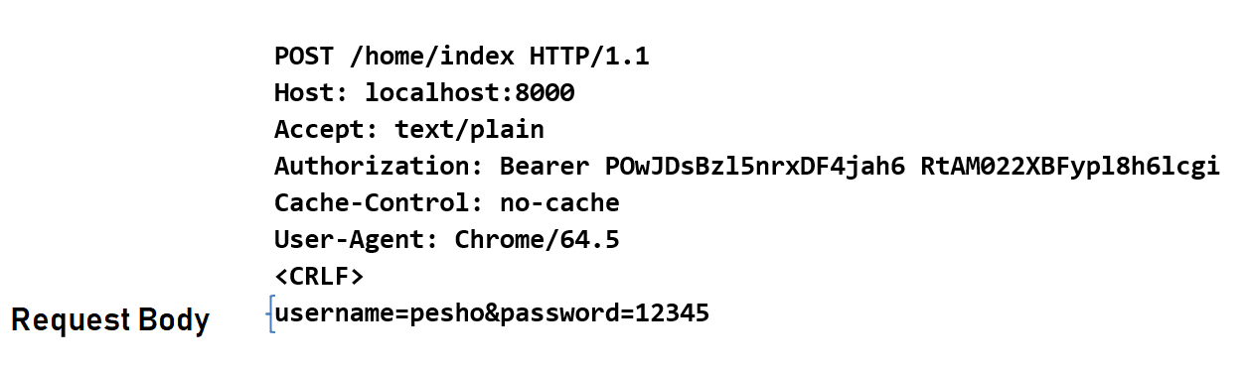

A POST Request is almost the same, except that it has a body. The Request Body holds parameters, which should be mapped to the Form Data Dictionary in the same way that query parameters are **mapped** to the Query Data Dictionary.

That’s a lot of things to do, which in itself means a lot of methods if you want to write High-Quality Code. Here is some hints. Implement the following methods:

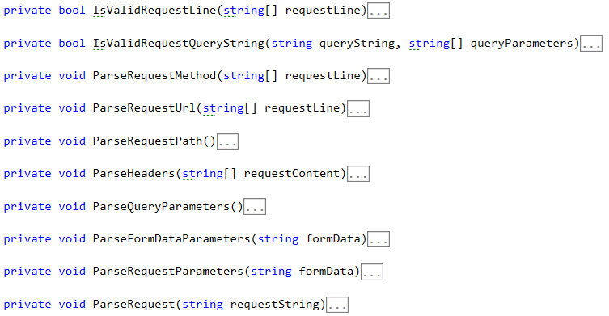

The ParseRequest() method is the root call:

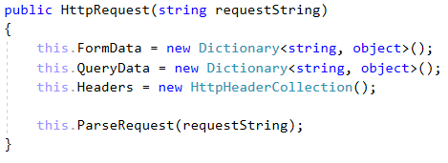

Now let’s see what it looks like:

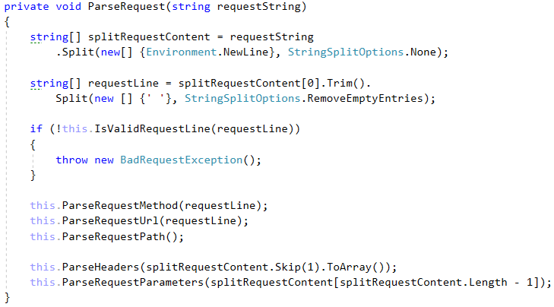

As you can see it splits the requestString, creating an array of lines. Then it takes the 1st line (The **Request Line**) and splits, creating the **split** requestLine. The method than proceeds with a sequence of **method** **calls** to **validate** and **map** the **string data** to the **properties**.

These methods will be **yours to** **implement**. You will, however, be explained, what each methods does, to ease your implementation, so let’s start!

##### IsValidRequestLine() Method

This method checks if the **split** requestLine **holds exactly 3 elements**, and if the **3rd element** is **equal** to “HTTP/1.1”. Returns a **boolean** result.

##### IsValidRequestQueryString() Method

This method is used in the ParseQueryParameters() method. It checks if the Query string is **NOT** **NULL** or **empty** and if there is **atleast 1** or more queryParameters.

##### ParseRequestMethod() Method

Sets the Request’s Method, by **parsing** the **1st element** from the **split** requestLine.

##### ParseRequestUrl() Method

Sets the Request’s Url to the **2nd element** from the **split** requestLine.

##### ParseRequestPath() Method

Sets the Request’s Path, by **splitting** the Request’s Url and taking **only** the **path** from it.

##### ParseHeaders() Method

Skipping the **first line** (the **request line**), **traverses** the **request lines** until it reaches an **empty line** (the **<CRLF> line**). Each line represents a header, which must be split and parsed. Then the **string data** is **mapped** to an HttpHeader **object**, and the **object** itself is **added** to the Headers property of the **Request**.

Throws a BadRequestException if there is no “Host” **Header** present **after** the **parsing**.

##### ParseQueryParameters() Method

Extracts the Query string, by **splitting** the Request’s Url and taking **only** the **query** from it. Then **splits** the Query string into **different parameters**, and **maps** each of them into the Query Data Dictionary.

**Validates** the Query string and parameters by calling the IsValidrequestQueryString() method.

Does **nothing** if the Request’s Url contains NO Query string.

Throws a BadRequestException if the Query string is **invalid**.

##### ParseFormDataParameters() Method

**Splits** the Request’s Body into **different parameters**, and **maps** each of them into the Form Data Dictionary.

Does **nothing** if the Request contains NO Body.

##### ParseRequestParameters() Method

Invokes the ParseQueryParameters() and the ParseFormDataParameters() methods. Just a wrapping method.

If you implement all methods **correctly**, you should be able to parse even complex requests with no problems.

### Responses Namespace

The Responses namespace will hold **classes** and **interfaces** for storing and manipulating data about **HTTP Responses**.

#### IHttpResponse

Create an interface, called IHttpResponse, which will describe the behaviour of a **Response object**.

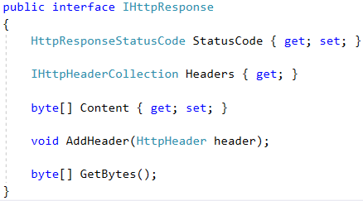

#### HttpResponse

Create a class, called HttpResponse, which implements the IHttpResponse interface. The class should implement the Interface’s methods,

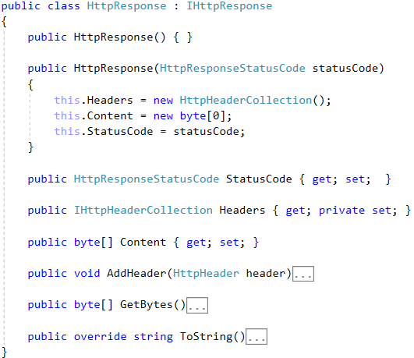

As you can see the HttpResponse holds its StatusCode, Headers, Content etc. These are the only things we will need for now. Unlike the Request, the Response is gradually being built, depending on the processing of the request. An HttpResponse is instantiated with an object with **NULL** or **default values**.

The **Server** receives **Requests** in **text format** and **should return Responses** in the **same format**.   
The string representations of the **HTTP Responses** are in the following format:

{protocol} {statusCode} {status}  
{header1key}: {header1value}  
{header2key}: {header2value}  
...  
<CRLF>  
{content}

**NOTE**: As you should already know, the content (**Response** **body**) is **optional**.

Now, while building our HttpResponse object, we can set its StatusCode or we can do that later in time. Normally, we would just set it upon **initialization** through the **constructor**.

##### AddHeader() Method

We can add Headers to it, gradually with the processing of the Request, using the AddHeader() method.

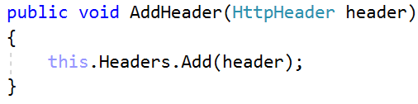

The other properties, StatusCode and Content can be set from outside using their **public setters**.

Now let’s see what the ToString() and GetBytes() methods do.

##### ToString() Method

The ToString() method forms the Response line – the line holding the protocol, the status code and the status, and the Response Headers along with the <CRLF> line. These properties are **concatenated** in a **string** and returned.

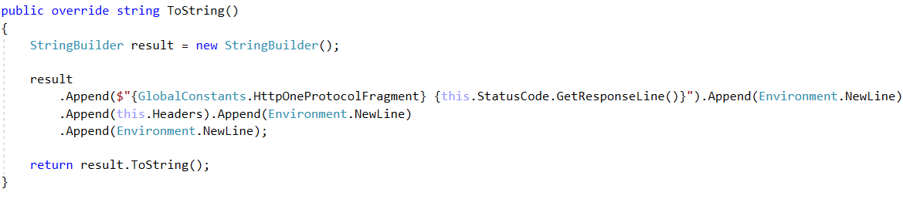

And now you might wonder, why is the Content of the Response a byte[] value, and why does the string representation of the Response not holding the Content. Well, that is because the Content can also be а direct file data, like **images** and **audio**. That is why we need a byte[] array to store that data.

And that’s where the GetBytes() method comes.

##### GetBytes() Method

The GetBytes() method **converts** the **result** from the ToString() method to a byte[] array, and **concatenates** to it the Content bytes, thus forming the full **Response** in **byte format**. Exactly what we need to send to the Client.

And with that we are finished with the **HTTP work** for now. We can proceed to the main functionality of the Server.

## SIS.WebServer Project Architecture

The **WebServer Project** will hold the main classes that **establish** the **connection** over **TCP Link**. These classes will use the ones from the **HTTP Project**. The Project will expose several classes, which should be used from the outside, in order to **implement** an **application**.

Create the following namespace and class architecture in the project:

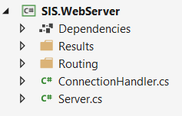

### Results Namespace

The Results namespace will hold **several classes** which **derive** from the HttpResponse class. These classes will be used to implement basic web applications using the SIS. There are 3 classes which you must put here – TextResult, HtmlResult and RedirectResult.

#### TextResult

Designed to hold text contents, this is a simple plain **text response**. It should have a Content-Type header – **text/plain**.

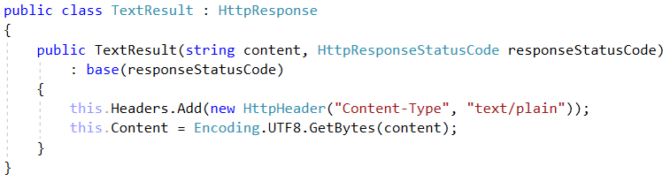

#### HtmlResult

Designed to hold HTML contents, this is a simple **HTML response**, with which we can return **HTML pages** or just **simple messages**. It should have a Content-Type header – **text/html**.

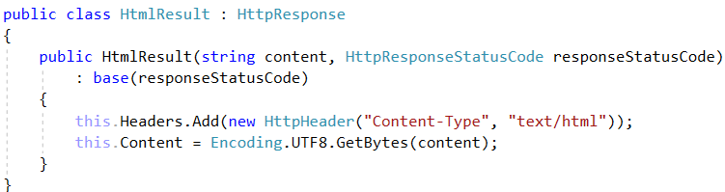

#### RedirectResult

Designed to hold **NO CONTENT**, and its only purpouse is to **redirect** the **client**. This **Response** has a **location** though. Its **status** is **predefined** also. It has status – SeeOther.

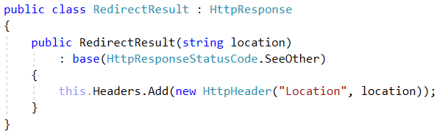

These are all the Results we need for basic application development.

### Routing Namespace

The Routing namespace will hold the **routing logic** and the **configuration** of the Server. It will hold only **1 class** for now – ServerRoutingTable.

This class holds a collosal collection of **nested dictionaries**, which will be used for **routing**:

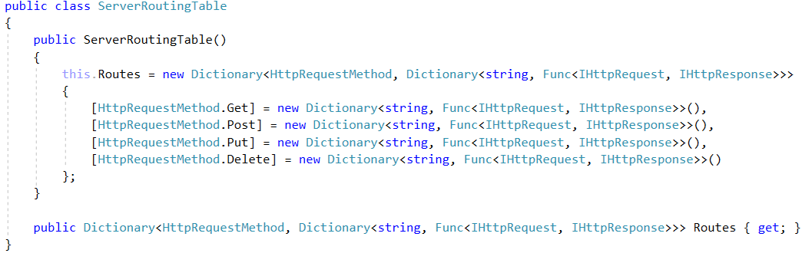

This is basically the main algorithm for **Request Handling**. A **Request Handler** is configured by **setting** the **Request Method** and the **Path** of the **Request**. Then the **Handler** itself is a **Function** which **accepts** a **Request** **parameter** and **generates** a **Response parameter**.

<Method, <Path, Func>>

We will see an example further below. Now let’s get to the real deal.

### Server class

The Server class is the main wrapper class for the **TCP connection**. It uses a TcpListener to capture Client connections and then passes them to the ConnectionHandler, which processes them.

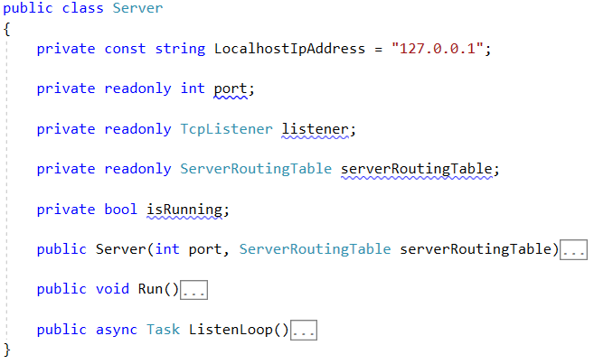

The **constructor** should be used to initialize the Listener and the RoutingTable.

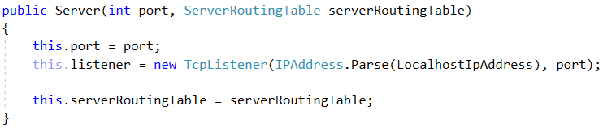

The Run() method should be used to **start** the **listening process**. Тhe listening process should be **asynchronous** to ensure **concurrent client functionality**.

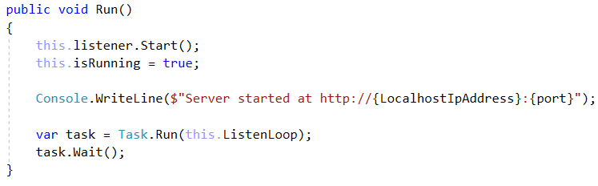

We also have a little message notifying us that nothing has exploded brutally in the process.

The ListenLoop() method is the main processing of the **client connection**:

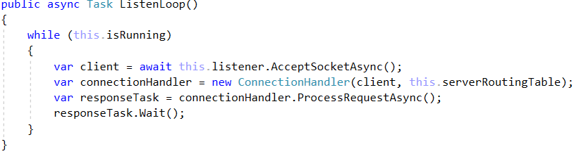

As you can see we **instantiate** a new ConnectionHandler for each client connection, and then we pass the client to the ConnectionHandler, along with the **routing table**, so that the **Request** can be **processed**.

### ConnectionHandler class

The ConnectionHandler class is the **client** **connection processor**. It receives the **connection**, **extracts** the **request** **string data** from it, **processes** it **using** the **routing table**, and then **sends back** the **Response** in a byte format, throughout the **TCP link**.

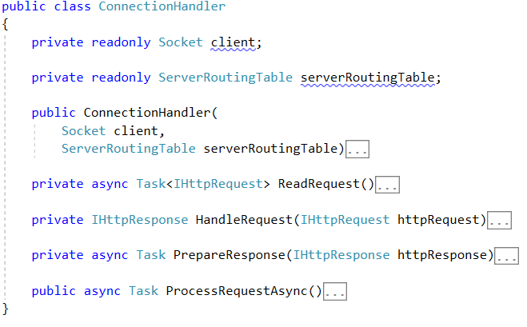

The constructor should just **initialize** the **socket** (the **wrapper object** for a **client connection**) and the **routing table**.

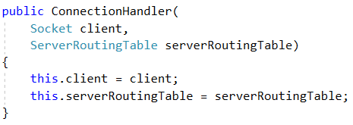

The ProcessRequestAsync() method is an **asynchronous** method which contains the main functionality of the class. It uses the other methods to **read** the **request**, **handle** it, **generate** a **response**, **send** it to the **client**, and finally, **close** the **connection**.

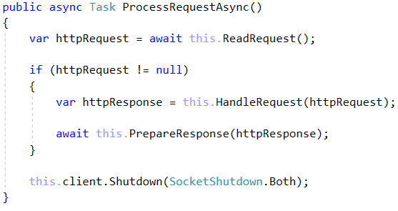

The ReadRequest() method is an **asynchronous** method which reads the **byte data** from the **client connection**, **extracts** the **request string data** from it, and then **maps** it to a HttpRequest object.

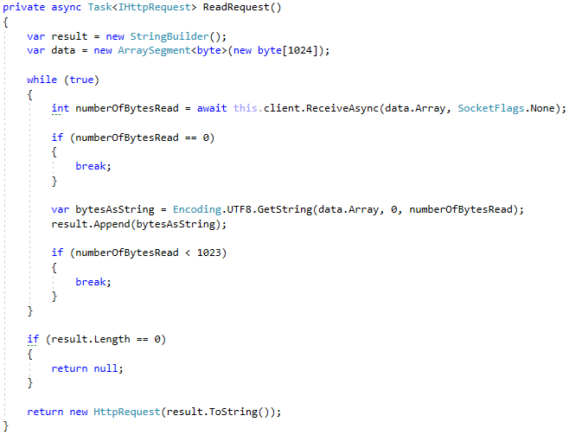

As you can see the **Requests** are quite limited to **1024 bytes**. This is intentional.

The HandleRequest() method **checks** if the **routing table** has a **handler** for the **given Request**, using the **Request’s** **Method** and **Path**.

* If there is **no such handler** a “Not Found” **Response** is returned.
* If there is a **handler**, its **function** is **invoked**, and its resulting **Response** – returned.

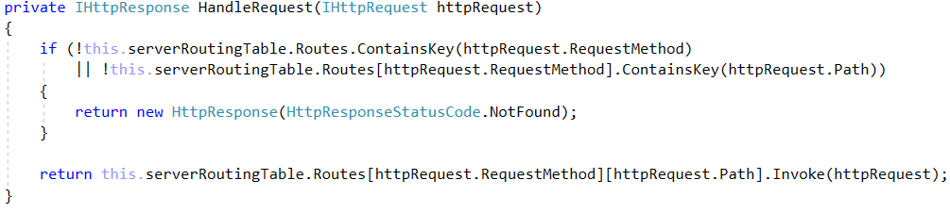

The PrepareResponse() method **extracts** the **byte data** from the **Response**, and **sends** it to the **client**.

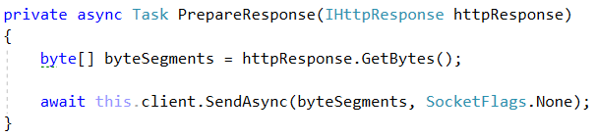

And with that we are finished with the ConnectionHandler and the **WebServer Project** as a whole. Now, before we embark on a journey to implement applications with our **SIS**. Let’s first check a very simple **Hello World! Demo app**.

## Hello, World!

Implement a third project called SIS.Demo. Reference both the SIS.HTTP and SIS.WebServer projects to it.

Create the following classes:

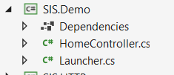

### HomeController

The HomeController class should hold a single method – Index() which looks like this:

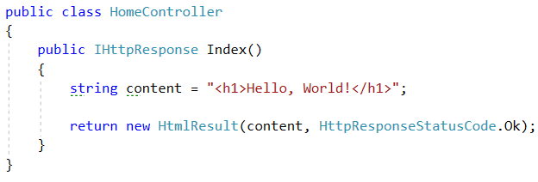

### Launcher

The Launcher class should hold the Main method, which instantiates a Server and **configures** it to **handle** **requests** using the ServerRoutingTable.

**Configure** only the “/” route with a **lambda function** which **invokes** the HomeController.Index method.

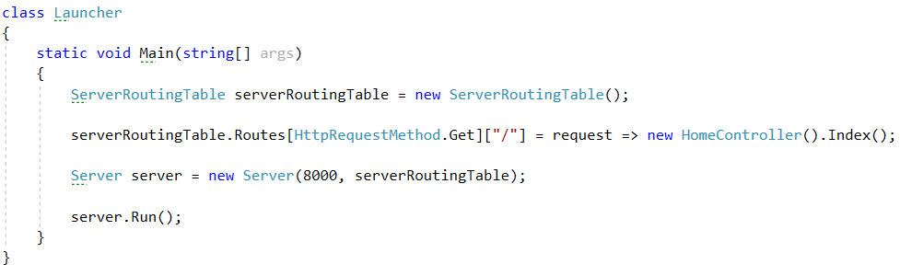

Now run the SIS.Demo project, and you should see this, if everything up until now was done correctly:

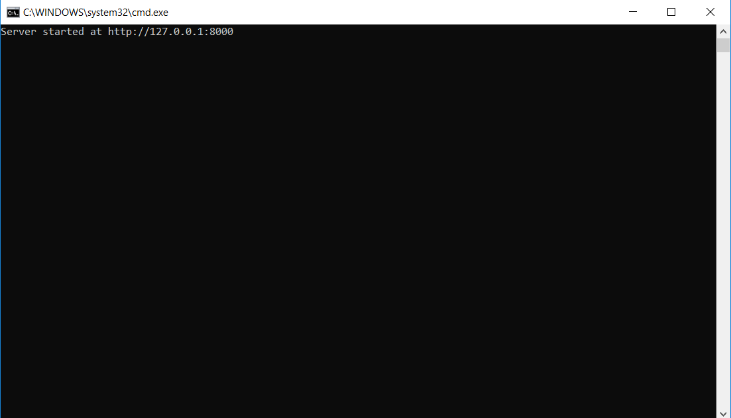

Open your browser, then go to localhost:8000. And you should see this.

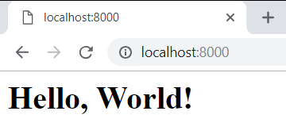

**Congratulations**! You have completed your first **Hello World app** with the SIS!